

MSc Data Science Project
7PAM2002
Department of Physics, Astronomy and Mathematics

Data Science FINAL PROJECT REPORT

Project Title:
Predictive Analysis of Maritime Accidents in the United Kingdom

Student Name and SRN:
Usman Ghani (24071234)

Supervisor: Hyungrok Kim
Date Submitted: 19 April 2026
Word Count: 4550
GitHub Link: https://github.com/usmanghani332211/Final-Project.git

DECLARATION STATEMENT

This report is submitted in partial fulfilment of the requirement for the degree of Master of Science in Data Science at the University of Hertfordshire.
I have read the detailed guidance to students on academic integrity, misconduct and plagiarism information at Assessment Offences and Academic Misconduct and understand the University process of dealing with suspected cases of academic misconduct and the possible penalties, which could include failing the project or course.
I certify that the work submitted is my own and that any material derived or quoted from published or unpublished work of other persons has been duly acknowledged. (Ref. UPR AS/C/6.1, section 7 and UPR AS/C/5, section 3.6)
I did not use human participants in my MSc Project.

I hereby give permission for the report to be made available on module websites provided the source is acknowledged.

Student Name printed: Usman Ghani

Student Name signature: usman

Student SRN number: 24071234

UNIVERSITY OF HERTFORDSHIRE
SCHOOL OF PHYSICS, ENGINEERING AND COMPUTER SCIENCE

Content

Table of Content
DECLARATION STATEMENT 2
INTRODUCTION 5
Background: 5
Importance of Injury Prediction: 5
Aim of the Study: 5
Objectives: 5
Research Question: 6
Machine Learning in Accident Prediction: 6
Deep Learning Approaches: 7
Comparison of Machine Learning Models: 7
Research Gap: 7
Summary: 8
Dataset Description: 8
Data Collection Details: 9
Initial Data Cleaning: 9
Feature Engineering: 9
Target Variable Selection and Cleaning: 10
Target Variable Selection and Cleaning: 10
Handling Class Imbalance: 11
The dataset exhibited significant class imbalance, with some injury types having very few observations. 11
Rare Class Merging 11
Undersampling 11
Train-Test Split: 11
Summary of Preprocessing Workflow: 11
Exploratory Data Analysis (EDA) 11
Target Variable Distribution 11
Numerical Feature Distribution 12
Injury Types by Ship Size: 13
3.9 Importance of Exploratory Analysis: 15
Model Training and Evaluation 16
Overview: 16
Logistic Regression: 16
Random Forest: 17
Gradient Boosting: 18
Multilayer Perceptron (MLP): 19
Model Performance Comparison: 21
Key Findings: 22
Summary: 22
Hyperparameter Optimisation: 23
Logistic Regression: 24
Random Forest: 24
Gradient Boosting: 25
Multilayer Perceptron: 26
Deep Neural Network: 27
Comparison of Baseline and Tuned Models 28
Key Observations: 29
Hyperparameter tuning improved model performance: 29
Random Forest achieved the best performance: 29
Neural networks did not outperform classical models: 29
Class imbalance remains a key challenge: 30
Gradient Boosting provided balanced performance: 30
Summary of Tuned Model Evaluation: 30
Conclusion: 31
Future Work: 32

Abstract
This study investigates the application of machine learning techniques for predicting injury types in United Kingdom maritime accidents using structured accident data from the Marine Accident Investigation Branch (MAIB), covering the period from 2010 to 2024. The project aims to evaluate the effectiveness of different classification models in identifying injury outcomes based on vessel characteristics, environmental conditions, and accident-related features.
A comprehensive data preprocessing pipeline was implemented, including data cleaning, feature engineering, encoding of categorical variables, and scaling of numerical features. Class imbalance was addressed through rare class merging and undersampling of the majority class. Exploratory data analysis was conducted to understand feature distributions and relationships within the dataset.
Five machine learning models were developed and evaluated: Logistic Regression, Random Forest, Gradient Boosting, Multilayer Perceptron (MLP), and a Deep Neural Network. Model performance was assessed using accuracy, precision, recall, and F1-score. Hyperparameter tuning was applied using GridSearchCV to improve model performance.
The results show that Random Forest achieved the highest accuracy of approximately 41% after tuning, followed by Logistic Regression and Gradient Boosting models. While models performed well on common injury categories, performance for minority classes remained limited due to class imbalance. Neural network models did not outperform classical machine learning approaches.
Overall, the study demonstrates that machine learning can provide useful insights for predicting injury types in maritime accidents; however, model performance is constrained by dataset characteristics, particularly class imbalance and limited feature diversity.

INTRODUCTION

Background:
Maritime transport plays a vital role in global trade and passenger movement. However, maritime accidents continue to pose significant risks to human life, vessel safety, and the environment. Understanding the causes and outcomes of such accidents is essential for improving safety measures and reducing injury rates.
The Marine Accident Investigation Branch (MAIB) collects and publishes detailed reports on maritime accidents in the United Kingdom. These reports include information on vessel type, environmental conditions, and injury outcomes, providing a valuable dataset for data-driven analysis.

Importance of Injury Prediction:
Predicting the type of injury resulting from maritime accidents can support:
- Risk assessment
- Safety planning
- Preventive decision-making
Machine learning techniques enable the analysis of large historical datasets to identify patterns and relationships that may not be easily observable through traditional methods.

Aim of the Study:
The aim of this study is:
To develop and evaluate machine learning models for predicting injury types in UK maritime accidents using historical accident data.

Objectives:
The objectives of this study are:
- To preprocess and analyse maritime accident data
- To address class imbalance using appropriate techniques
- To train multiple machine learning models
- To compare model performance using evaluation metrics
- To improve performance through hyperparameter tuning
- To identify the most effective model for injury prediction

Research Question:
Can machine learning models accurately predict injury types in UK maritime accidents using structured accident data?
LITERATURE REVIEW
Introduction:
Maritime accidents represent a significant safety concern, leading to injuries, fatalities, and economic losses. With the increasing availability of structured accident data, machine learning has emerged as a powerful tool for analysing accident patterns and predicting outcomes. This section reviews relevant literature on maritime accident prediction and compares the methods used in previous studies with those implemented in this project.
The selected papers were chosen based on the following criteria:
- Use of machine learning techniques for accident prediction
- Application to maritime or transportation safety domains
- Publication in peer-reviewed journals or conference proceedings

Machine Learning in Accident Prediction:
Lan et al. (2024) developed a machine learning framework for predicting types of maritime accidents using ensemble models. Their study utilised a large maritime dataset and applied models such as Random Forest and Gradient Boosting. The results showed that ensemble models achieved high predictive accuracy and were particularly effective in handling complex relationships between variables.
However, the study relied on a larger dataset than the one used in this project, which may limit direct comparability. Despite this, the strong performance of ensemble models supports their inclusion in this study.
Similarly, Feng et al. (2024) applied gradient boosting techniques, including LightGBM, to predict accident severity. Their results demonstrated that boosting models can achieve high accuracy due to their ability to iteratively correct errors from previous models. The study also highlighted the importance of feature engineering and model optimisation.
A limitation of this work is that it focused primarily on accident severity rather than multi-class injury type prediction. In contrast, this project addresses a more complex classification problem involving multiple injury categories

Deep Learning Approaches:
Nourmohammadi (2023) explored the use of deep learning models for maritime risk prediction. The study incorporated environmental variables and vessel characteristics and showed that deep neural networks can capture complex non-linear relationships.
However, the results indicated that deep learning performance is highly dependent on dataset size and feature quality. In smaller or structured datasets, deep learning models may not outperform traditional machine learning methods.
This limitation is particularly relevant to this project, where the dataset is structured and relatively limited in size. As a result, deep learning models are included for comparison rather than as the primary approach.

Comparison of Machine Learning Models:
Previous research consistently shows that:
- Random Forest performs well due to its ability to handle non-linear relationships and reduce overfitting (Breiman, 2001)
- Gradient Boosting achieves strong performance through iterative error correction (Friedman, 2001)
- Logistic Regression remains effective as a baseline model for structured data
- Deep learning models require large datasets to outperform classical methods (Shwartz-Ziv and Armon, 2022)
These findings suggest that model performance depends not only on algorithm complexity but also on dataset characteristics such as size, structure, and class distribution.

Research Gap:
Although previous studies have explored accident prediction, several gaps remain:
- Limited focus on multi-class injury type prediction
- Lack of comparison between classical and deep learning models on the same dataset
- Insufficient analysis of class imbalance handling techniques
This project addresses these gaps by:
- Implementing multiple models
- Comparing their performance
- Evaluating the impact of class imbalance

Summary:
The literature demonstrates that machine learning is effective for accident prediction, particularly ensemble models. However, model performance is influenced by dataset characteristics and class imbalance.
The findings from previous studies informed the selection of models and methods used in this project. The results obtained in this study are consistent with the literature, confirming that classical machine learning approaches remain highly effective for structured datasets.

METHODOLOGY

Dataset Description:
The dataset used in this study was obtained from the Marine Accident Investigation Branch (MAIB), United Kingdom, and compiled by Fijabi J. Adekunle (2025).
The dataset spans a period from 2010 to 2024 and includes detailed records of maritime accidents involving UK vessels. The data was collected through official investigations and mandatory reporting procedures, ensuring high reliability and accuracy.
The dataset includes features such as:
- Vessel type
- Gross tonnage
- Weather conditions
- Location
- Injury type
- Accident description
These features provide a comprehensive view of accident conditions and outcomes.

Data Collection Details:
- Who collected the data:
Marine Accident Investigation Branch (MAIB), UK Government
- When the data was collected:
From 2010 to 2024, recorded continuously as accidents occurred
- Where the data was collected:
United Kingdom territorial waters and incidents involving UK-registered vessels worldwide
- How the data was collected:
Through official maritime accident reports, investigations, and mandatory incident reporting procedures
This dataset contains structured information about maritime accidents, including vessel characteristics, environmental conditions, and injury outcomes.

Initial Data Cleaning:
Prior to analysis, initial data cleaning steps were applied to ensure data quality and consistency. Duplicate records were removed to prevent biased model learning. Column names were standardized by converting them to lowercase and replacing spaces with underscores, improving code readability and reproducibility.
The date attribute was converted to a datetime format to enable temporal feature extraction in later stages of preprocessing.
Purpose of this step:
- Remove redundant information
- Ensure consistent feature naming
- Prepare temporal data for feature engineering

Feature Engineering:
Additional feature engineering was performed to enrich the dataset and improve model performance. Temporal features such as year and month were extracted from the accident date, allowing models to capture seasonal or long-term trends in maritime accidents.
High-cardinality textual fields such as unique identifiers and narrative descriptions were removed, as these features are unsuitable for classical machine learning models and could introduce noise. Furthermore, a binary feature indicating the presence of fatalities was derived from the fatalities count, providing a simplified representation of accident severity.
Feature engineering steps included:
- Extraction of year and month from accident date
- Removal of free-text and identifier columns
- Creation of a binary fatality indicator
These steps improved model generalization while maintaining interpretability.

Target Variable Selection and Cleaning:
The target variable selected for this study was injury_type, representing the type of injury sustained during a maritime accident. This choice enables a multi-class classification problem, allowing models to distinguish between different injury outcomes such as bone fractures, sprains, and other injury categories.
Records containing missing target labels were removed prior to model training. Imputation of target variables is methodologically inappropriate in supervised learning, as it may introduce artificial labels and bias model evaluation.
A stratified train–test split was then applied to preserve the original class distribution across training and testing datasets.
Justification:
- Ensures valid supervised learning setup
- Prevents label noise
- Maintains class balance for fair evaluation

Target Variable Selection and Cleaning:
The target variable selected for this study was injury_type, representing the type of injury sustained during a maritime accident. This choice enables a multi-class classification problem, allowing models to distinguish between different injury outcomes such as bone fractures, sprains, and other injury categories.
Records containing missing target labels were removed prior to model training. Imputation of target variables is methodologically inappropriate in supervised learning, as it may introduce artificial labels and bias model evaluation.
A stratified train–test split was then applied to preserve the original class distribution across training and testing datasets.
Justification:
- Ensures valid supervised learning setup
- Prevents label noise
- Maintains class balance for fair evaluation

Handling Class Imbalance:

The dataset exhibited significant class imbalance, with some injury types having very few observations.
To address this issue:

Rare Class Merging
Classes with fewer than ten observations were merged into a single category. This reduces noise and improves model learning.

Undersampling
The majority class was reduced in the training dataset to create a more balanced distribution. This helps prevent the model from being biased towards dominant classes.

Train-Test Split:
A 60/40 stratified split was used. Stratification ensures that the distribution of injury types remains consistent across training and testing datasets.
This approach improves the reliability of model evaluation.

Summary of Preprocessing Workflow:
The complete preprocessing workflow included:
- Data cleaning and standardization
- Feature engineering and dimensionality reduction
- Careful target selection and label cleaning
- Stratified data splitting
- Unified preprocessing using pipelines
This structured approach aligns with best practices in applied data science and ensures methodological rigor for subsequent model development.

Exploratory Data Analysis (EDA)
Prior to model training, exploratory data analysis was conducted to better understand the distribution of key variables and identify potential challenges for machine learning models.

Target Variable Distribution
This Figure illustrates the distribution of injury types in the training dataset. The target variable exhibits noticeable class imbalance, with certain injury categories occurring more frequently than others. This imbalance reflects real-world maritime accident reporting patterns and justifies the use of stratified sampling during the train–test split.
Understanding the target distribution is critical, as class imbalance can influence model performance and evaluation metrics. This observation informed later modeling decisions, including the choice of evaluation measures beyond simple accuracy.
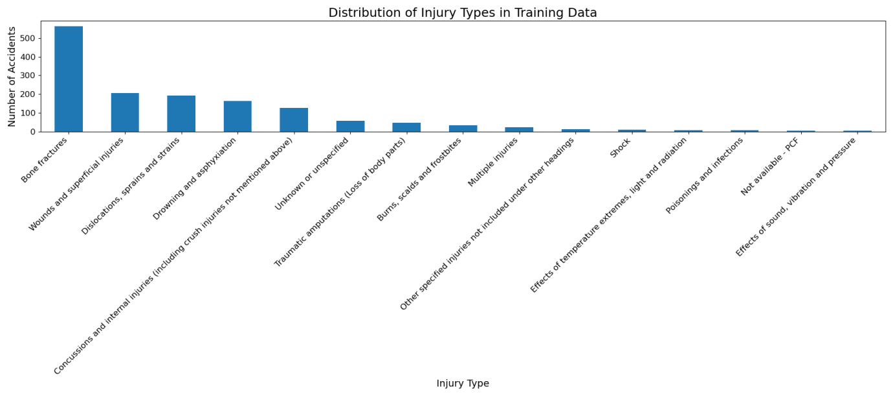

Numerical Feature Distribution
This Figure presents the distribution of vessel gross tonnage across reported accidents. The distribution is highly right-skewed, with a small number of very large vessels and a large number of smaller vessels.
This skewness motivated the application of feature scaling during preprocessing, ensuring that numerical variables with large magnitudes do not disproportionately influence model learning.
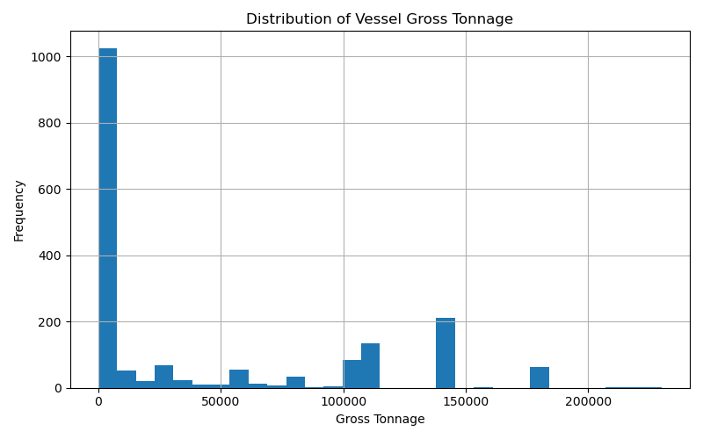

Injury Types by Ship Size:
This figure presents the distribution of injury types across different ship sizes, categorised as small ships and large ships. The results indicate that injury occurrences vary significantly depending on vessel size.
Bone fractures are the most frequent injury type for both small and large ships, with a notably higher number observed in large vessels. This may be attributed to the higher number of passengers and crew typically present on larger ships, increasing the likelihood of accidents.
Similarly, dislocations, sprains, and strains are more common in large ships, suggesting that physical movement and operational activities on larger vessels contribute to such injuries.
In contrast, certain injury types such as drowning and asphyxiation appear relatively higher in small ships compared to large ships. This may be due to the increased exposure to environmental risks and lower safety infrastructure in smaller vessels.
Rare injury categories, including traumatic amputations and shock, show very low frequencies across both ship types, indicating that such incidents are uncommon regardless of vessel size.
Overall, the results suggest that ship size plays a role in the distribution of injury types, with larger vessels experiencing a higher frequency of common injuries, while smaller vessels may be associated with more severe or environment-related risks.
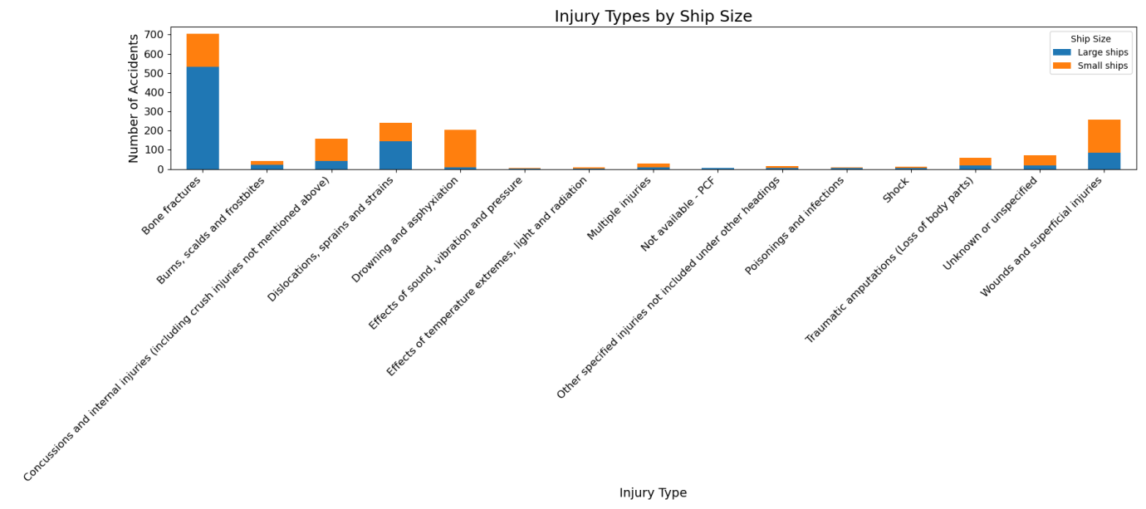
Total Number of Injuries by Ship Size:
This figure illustrates the total number of injuries recorded for small and large ships. The results show that both categories have a similar number of total injury incidents, with small ships having a slightly higher count than large ships.
This finding suggests that while large ships may have more structured safety systems, the overall exposure to accidents remains comparable across vessel sizes. The slightly higher number of injuries in small ships may be attributed to limited safety measures, smaller crew sizes, and greater exposure to environmental conditions.
Despite the similarity in total injury counts, the distribution of injury types differs between ship sizes, as observed in Figure X. This highlights the importance of considering both the quantity and nature of injuries when analysing maritime accident data.
The results indicate that ship size alone does not determine the total number of accidents but may influence the type and severity of injuries sustained.
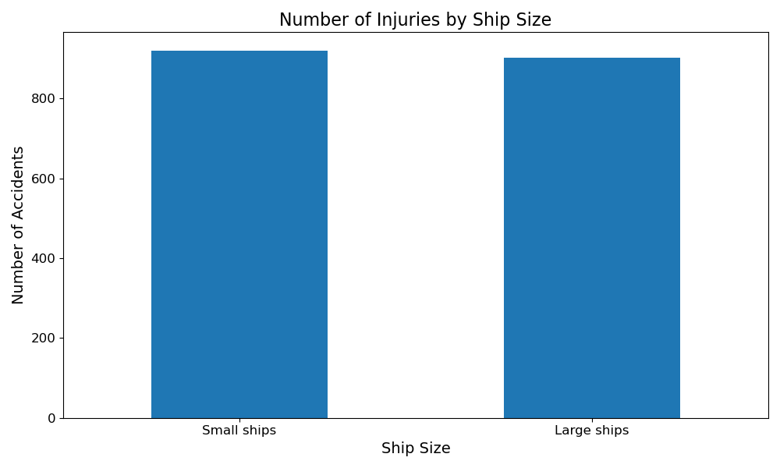

3.9 Importance of Exploratory Analysis:
Exploratory data analysis provided valuable insights into feature distributions, class balance, and data quality. These insights directly informed preprocessing choices such as scaling, stratified sampling, and categorical encoding strategies. Conducting EDA prior to modeling ensured that subsequent machine learning experiments were grounded in an informed understanding of the dataset.
Ethical Considerations
This study uses a secondary dataset obtained from the Marine Accident Investigation Branch (MAIB), a United Kingdom government organisation responsible for investigating maritime accidents. The dataset contains structured information about accident events, vessel characteristics, and injury outcomes.
No personal or identifiable information is included in the dataset. All records are anonymised and relate to incidents rather than individuals. Therefore, the dataset does not raise concerns related to personal privacy or confidentiality, and it does not fall under General Data Protection Regulation (GDPR) restrictions.
The data was collected by MAIB through official investigations and mandatory reporting procedures, indicating that it originates from a reputable and authoritative source. As a result, it is reasonable to assume that the data was collected ethically and in accordance with relevant legal and regulatory standards.
This project did not involve direct interaction with human participants, surveys, or data collection from individuals. Therefore, no ethical approval from the University of Hertfordshire was required for this study.
The dataset is publicly available and used for research purposes. Proper acknowledgement of the data source has been provided in this report. All analysis conducted in this project was performed responsibly, with the aim of improving maritime safety and understanding injury patterns without causing harm or misrepresentation.

Model Training and Evaluation

Overview:
Five machine learning models were implemented to predict the type of injury occurring in UK maritime accidents:
- Logistic Regression
- Random Forest
- Gradient Boosting
- Multilayer Perceptron (MLP)
- Deep Neural Network (DNN)
Prior to model training, rare injury categories with fewer than ten observations were merged into a single category labelled “Other_Rare_Injuries.” Additionally, the dominant class (“Bone fractures”) was reduced within the training dataset through random undersampling in order to reduce class imbalance.
A 60/40 stratified train–test split was used to ensure sufficient evaluation data while preserving the proportional distribution of injury categories.
Model performance was evaluated using accuracy, precision, recall, and F1-score.

Logistic Regression:
The Logistic Regression model achieved the highest overall accuracy among all evaluated models.
Accuracy: 0.389 (38.9%)
The model demonstrated strong performance for the dominant injury category:
- Bone fractures: F1-score = 0.63
- Drowning and asphyxiation: F1-score = 0.37
However, the model struggled to identify certain minority classes such as traumatic amputations and unknown injury types.
The macro-average F1-score (0.22) indicates limited performance across all classes equally, while the weighted F1-score (0.37) reflects better performance for frequently occurring injury types.
Overall, Logistic Regression performed well as a baseline model despite its linear nature.
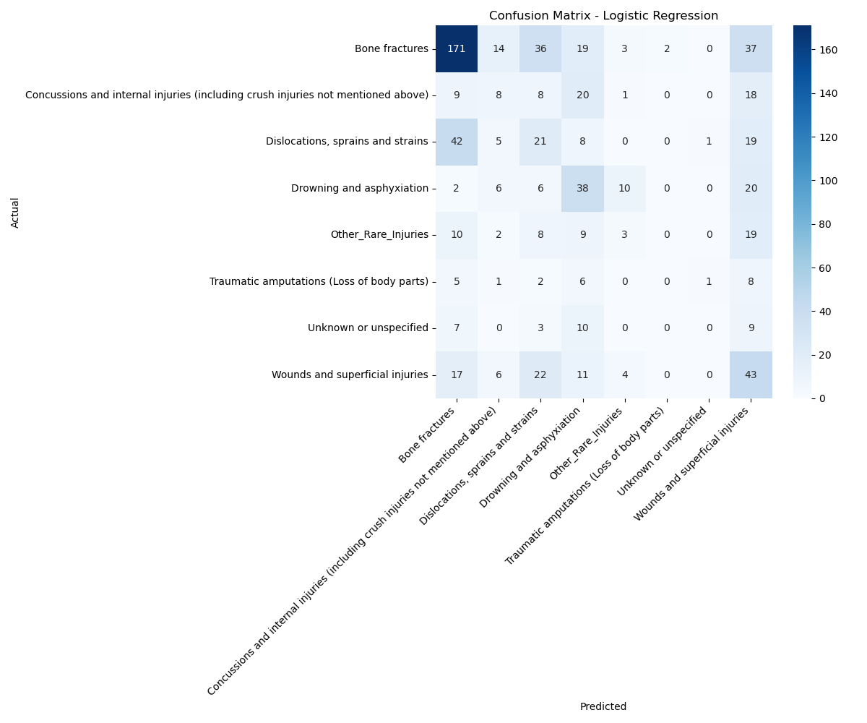

Random Forest:
The Random Forest classifier achieved an overall accuracy of:
Accuracy: 0.316 (31.6%)
The model demonstrated moderate predictive capability for several classes:
- Bone fractures: F1-score = 0.50
- Drowning and asphyxiation: F1-score = 0.44
However, predictive performance for minority injury categories remained limited.
The macro-average F1-score (0.22) suggests similar performance across categories compared with Logistic Regression, though overall accuracy was lower.
While Random Forest is often effective for structured data, it did not outperform simpler models in this study.

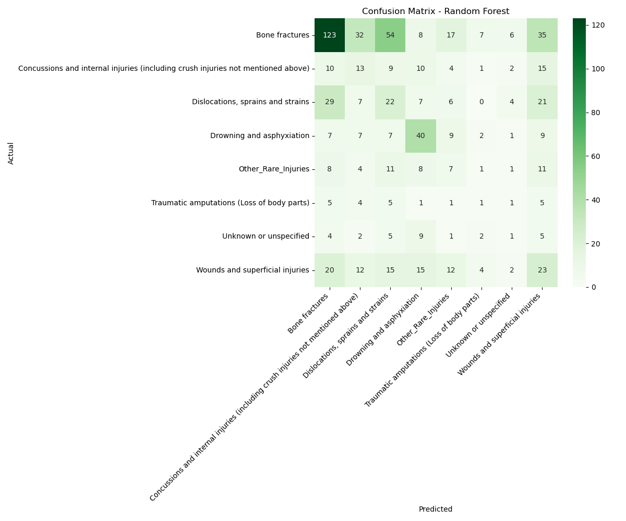

Gradient Boosting:
The Gradient Boosting classifier achieved strong performance relative to other models.
Accuracy: 0.384 (38.4%)
This model showed particularly strong performance for dominant injury types:
- Bone fractures: F1-score = 0.60
- Drowning and asphyxiation: F1-score = 0.45
Gradient Boosting also demonstrated slightly improved balance across categories, achieving the highest macro-average F1-score (0.25) among all models.
The weighted F1-score (0.38) further indicates that Gradient Boosting provided the most consistent performance across the dataset.
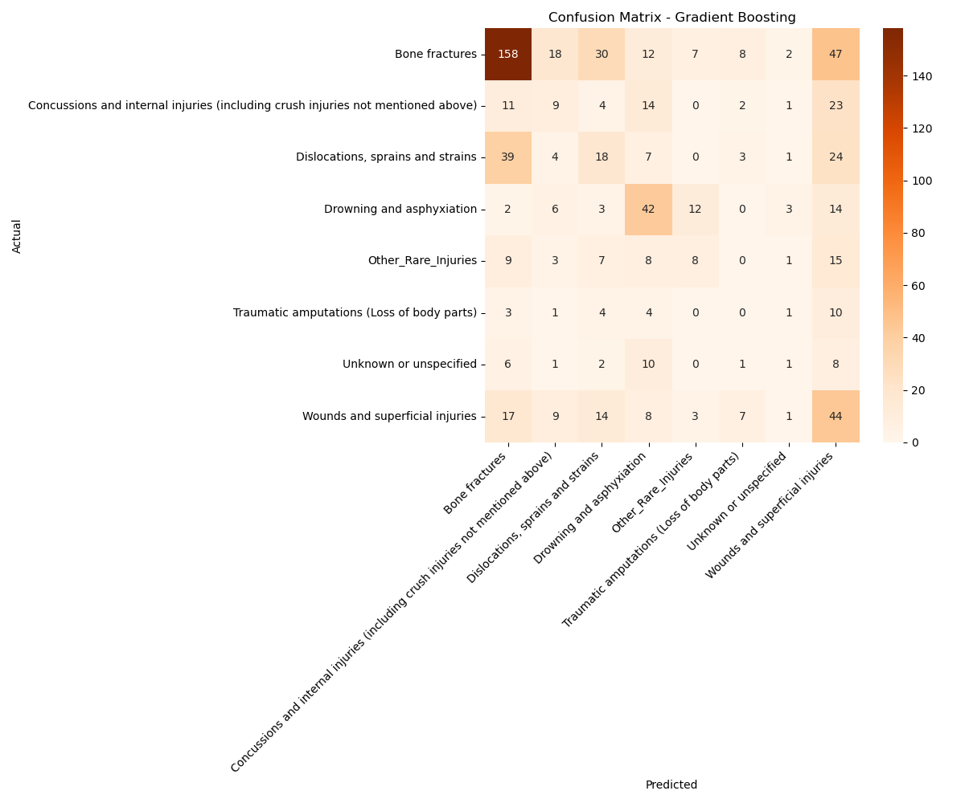

Multilayer Perceptron (MLP):
A neural network model was implemented using Scikit-learn’s Multilayer Perceptron (MLPClassifier) with multiple hidden layers.
Accuracy: 0.297 (29.7%)
Although the model captured some non-linear relationships within the data, overall performance was lower compared to classical machine learning models.
The model achieved moderate results for:
- Bone fractures: F1-score = 0.45
- Drowning and asphyxiation: F1-score = 0.37
However, the macro-average F1-score (0.21) suggests limited balanced performance across all classes.
These results indicate that the neural network did not provide a significant advantage over simpler models for this structured dataset.
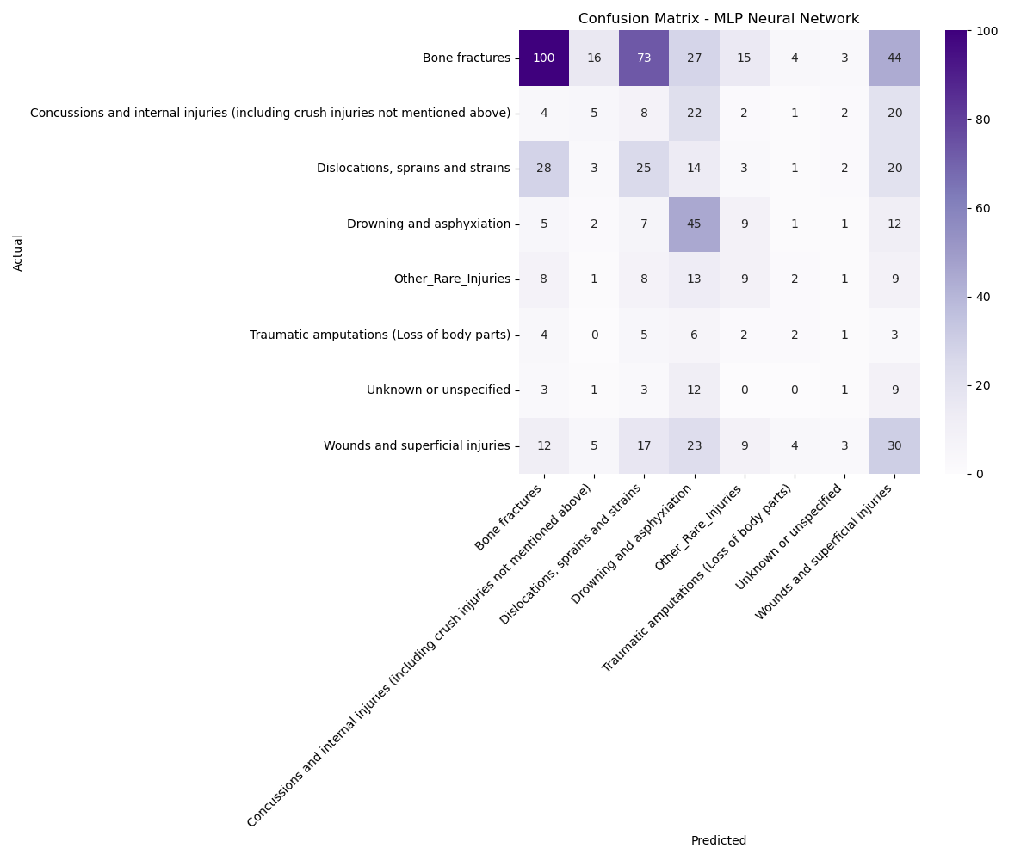
Deep Neural Network:
A deeper feed-forward neural network was implemented using TensorFlow/Keras with three hidden layers and dropout regularisation.
The model was trained for 40 epochs, during which training accuracy increased steadily from approximately 25% to over 53%. However, validation accuracy stabilised around 31–35%, suggesting mild overfitting.
Final evaluation on the test dataset produced:
Accuracy: 0.311 (31.1%)
Despite the increased architectural complexity, the deep neural network did not outperform classical models such as Logistic Regression or Gradient Boosting.
This suggests that deeper architectures may not provide substantial advantages for structured tabular datasets such as maritime accident records.
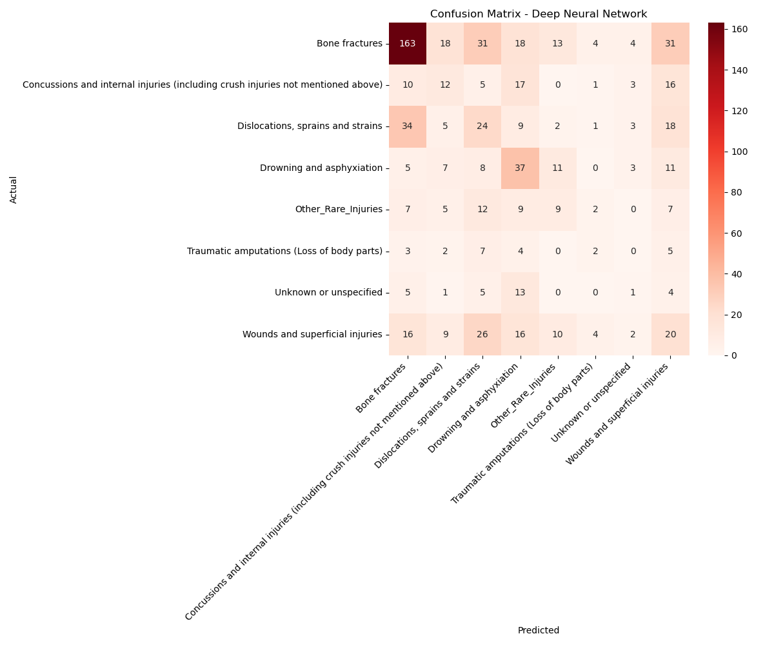

Model Performance Comparison:
Model | Accuracy | Macro F1 | Weighted F1
Logistic Regression | 0.389 | 0.22 | 0.37
Random Forest | 0.316 | 0.22 | 0.33
Gradient Boosting | 0.384 | 0.25 | 0.38
MLP | 0.297 | 0.21 | 0.30
Deep Neural Network | 0.311 | ~0.23 | ~0.31

Key observations include:
- Logistic Regression achieved the highest overall accuracy.
- Gradient Boosting achieved the best macro-level performance.
- Neural networks did not outperform classical models.
- Class imbalance continues to affect minority class prediction.
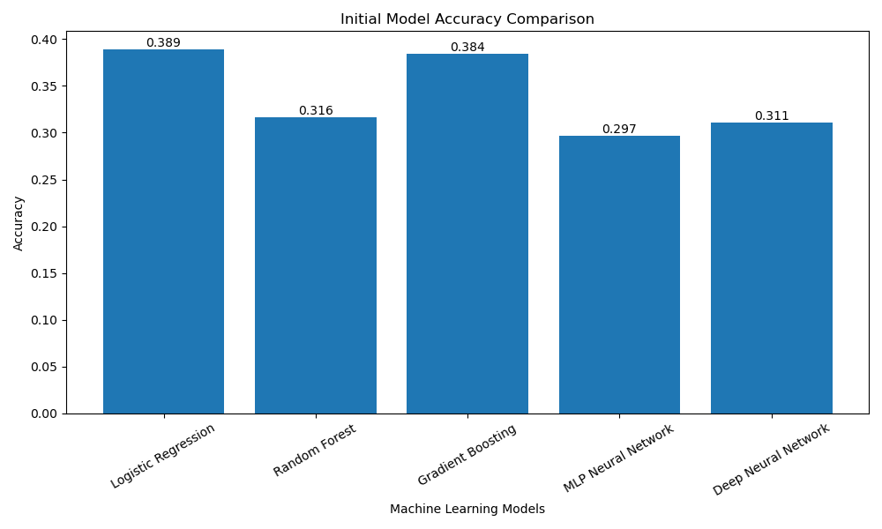

Key Findings:
Several important observations emerge from the model comparison:
- Classical machine learning models performed competitively, often outperforming neural network architectures.
- Gradient Boosting provided the most balanced performance across injury categories.
- Neural network models showed limited improvement, suggesting that the structured nature of the dataset may not benefit significantly from deep learning approaches.
- Class imbalance remains a major challenge, as dominant injury categories were predicted more accurately than rare categories.

Summary:
Overall, the results indicate that predicting injury types from maritime accident data is feasible but remains challenging due to class imbalance and limited dataset size.
Among the evaluated models, Logistic Regression and Gradient Boosting demonstrated the best overall performance, while neural network models did not provide substantial improvements despite increased model complexity.
These findings suggest that for structured maritime accident datasets, classical machine learning approaches remain highly effective.
The experimental results demonstrate that model complexity alone does not guarantee improved predictive performance, and that dataset characteristics such as class distribution play a critical role in determining model effectiveness.

Hyperparameter Tuning and Optimised Model Evaluation

Hyperparameter Optimisation:
Following the evaluation of baseline models, hyperparameter tuning was conducted to improve model performance and enhance generalisation capability. Hyperparameters control the learning process of machine learning models and can significantly influence predictive performance.
In this study, GridSearchCV with 5-fold cross-validation was used to systematically explore combinations of hyperparameters for each model. The optimisation objective was to maximise the weighted F1-score, as it provides a balanced evaluation metric for imbalanced multi-class classification problems.
The tuning process was applied to the following models:
- Logistic Regression (regularisation strength and solver)
- Random Forest (number of trees, depth, and split criteria)
- Gradient Boosting (learning rate, number of estimators, tree depth)
- Multilayer Perceptron (network architecture and learning parameters)
For the Deep Neural Network, hyperparameters such as layer size, dropout rate, and number of epochs were adjusted manually due to limitations of GridSearchCV with Keras models.

Tuned Model Performance:

Logistic Regression:
Accuracy: 0.40
The tuned Logistic Regression model maintained strong performance and showed slight improvement over the baseline model.
- Bone fractures: F1-score = 0.65
- Drowning and asphyxiation: F1-score = 0.39
The model continued to perform well for dominant classes, while performance for minority classes remained limited.
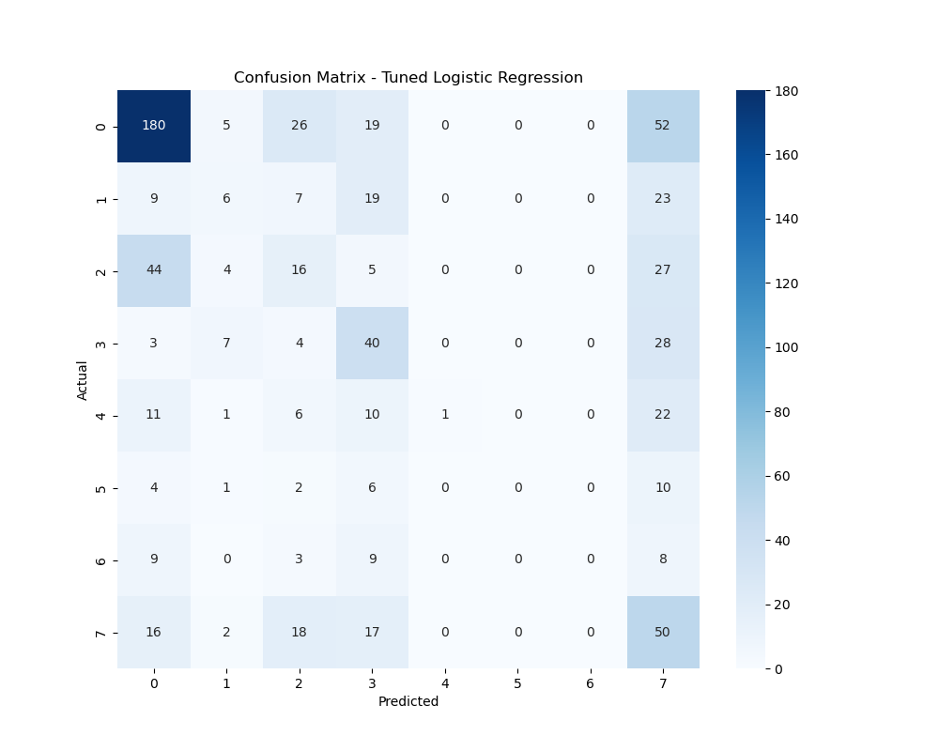

Random Forest:
Accuracy: 0.41 (Highest among all models)
The tuned Random Forest model achieved the best overall accuracy after optimisation.
- Bone fractures: F1-score = 0.63
- Drowning and asphyxiation: F1-score = 0.50
However, the model still failed to predict certain rare classes, such as traumatic amputations and unknown injury types, resulting in zero F1-scores for these categories.
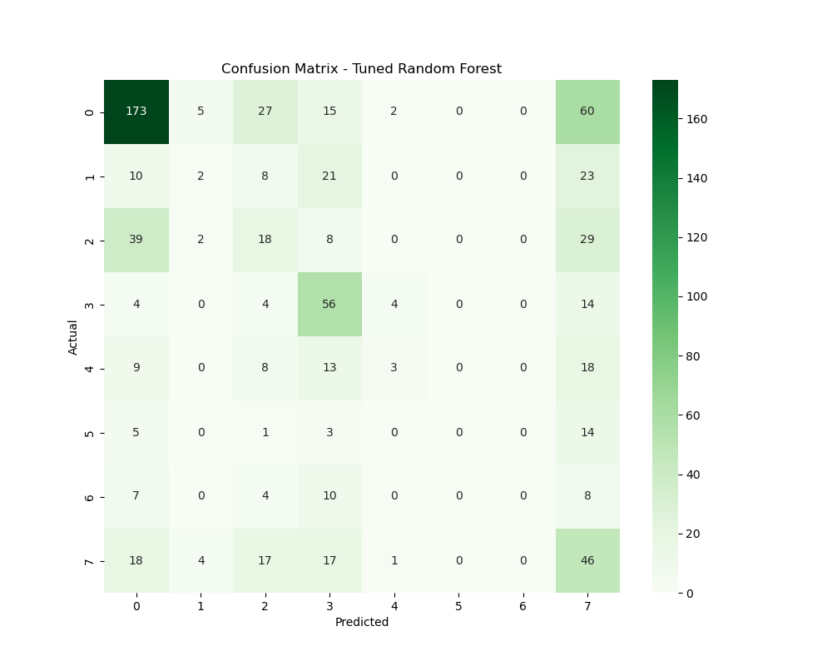

Gradient Boosting:
Accuracy: 0.39
The tuned Gradient Boosting model demonstrated strong and balanced performance:
- Bone fractures: F1-score = 0.62
- Drowning and asphyxiation: F1-score = 0.44
It achieved one of the highest weighted F1-scores (0.38), indicating consistent performance across the dataset.
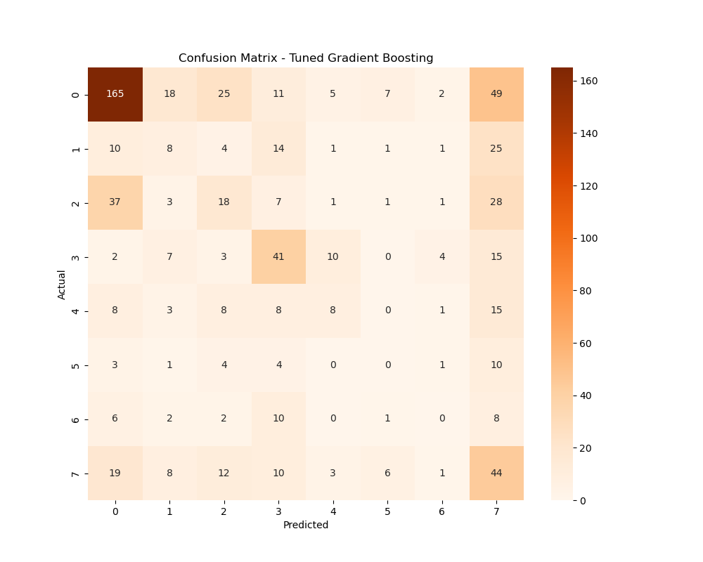

Multilayer Perceptron:
Accuracy: 0.28
The tuned MLP model showed limited improvement and remained the weakest performing model.
- Bone fractures: F1-score = 0.37
- Drowning and asphyxiation: F1-score = 0.40
The model struggled to generalise effectively across classes, particularly for minority injury types.
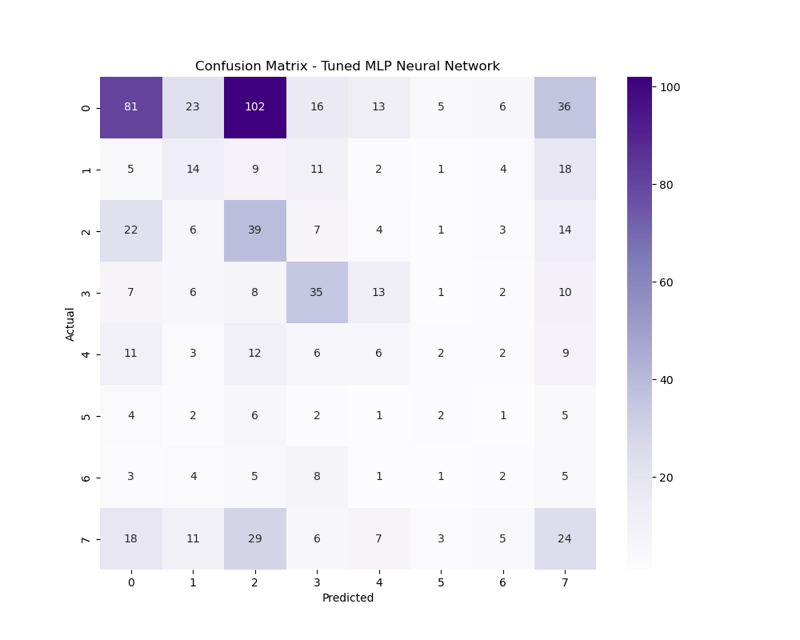

Deep Neural Network:
Accuracy: 0.35
The Deep Neural Network showed moderate improvement after tuning.
- Bone fractures: F1-score = 0.61
- Drowning and asphyxiation: F1-score = 0.32
Despite increased model complexity, performance remained comparable to classical models, indicating limited benefit from deeper architectures for this dataset.
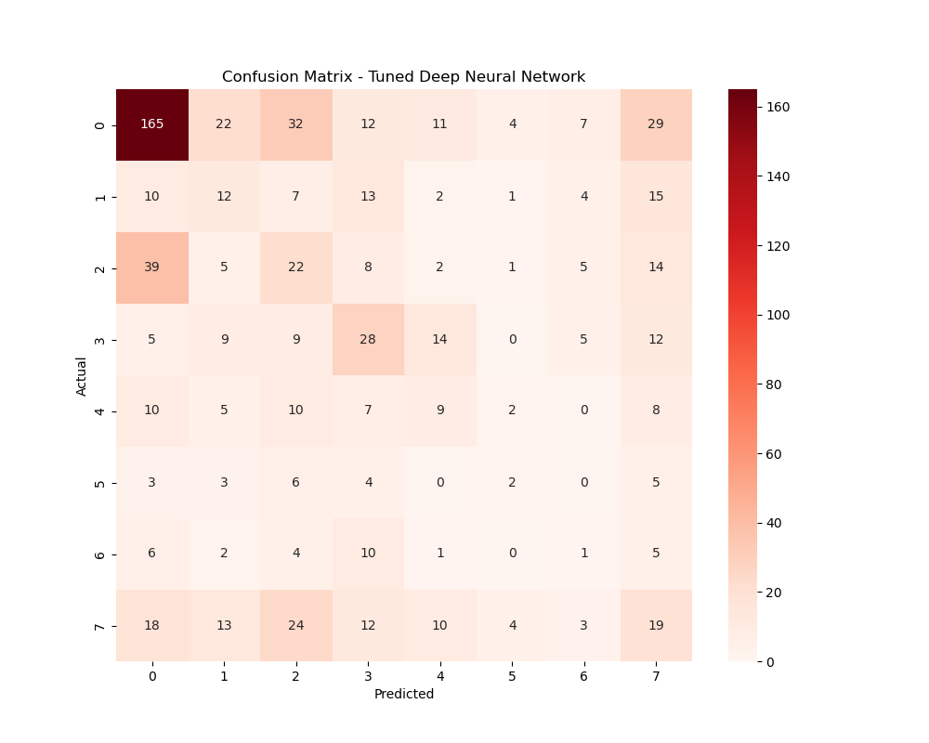

Comparison of Baseline and Tuned Models
Model | Baseline Accuracy | Tuned Accuracy
Logistic Regression | 0.389 | 0.40
Random Forest | 0.316 | 0.41
Gradient Boosting | 0.384 | 0.39
MLP | 0.297 | 0.28
Deep Neural Network | 0.311 | 0.35

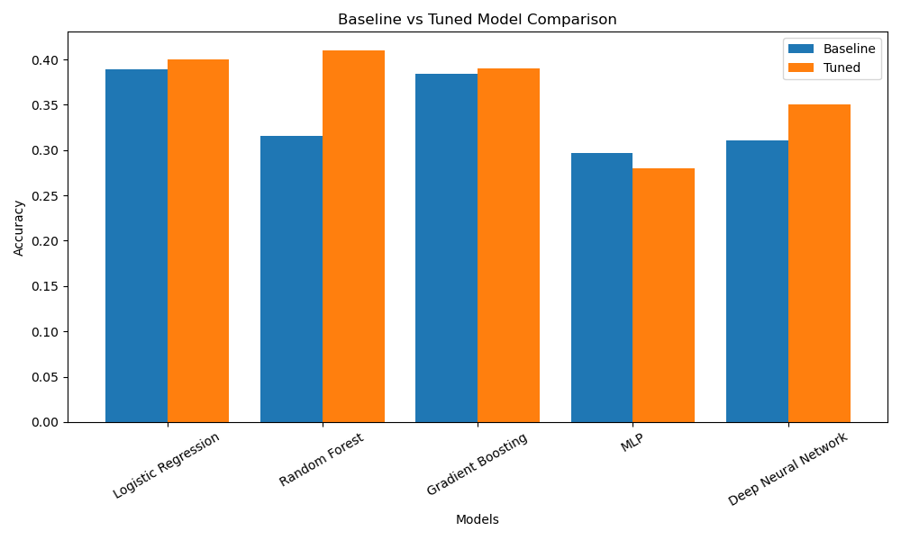

Key Observations:
Several important findings emerge from the tuned model results:

Hyperparameter tuning improved model performance:
- Random Forest showed the largest improvement
- Logistic Regression and Deep Neural Network also improved
- Gradient Boosting remained stable but consistent

Random Forest achieved the best performance:
The tuned Random Forest model achieved the highest accuracy (41%) and strong performance for major injury categories, making it the best-performing model overall.

Neural networks did not outperform classical models:
Despite increased complexity:
- MLP performed the worst
- Deep Neural Network showed only moderate improvement
This suggests that:
Structured tabular data does not significantly benefit from deep learning models.

Class imbalance remains a key challenge:
All models:
- Performed well on dominant classes (e.g., bone fractures)
- Performed poorly on rare classes (e.g., amputations)
This is reflected in:
- Low macro F1-scores (~0.21–0.24)
- Zero scores for some classes

Gradient Boosting provided balanced performance:
Although not the highest in accuracy, Gradient Boosting achieved:
- Strong weighted F1-score
- Consistent performance across classes

Summary of Tuned Model Evaluation:
The application of hyperparameter tuning improved overall model performance, particularly for ensemble methods such as Random Forest.
However, results indicate that:
- Model performance is primarily constrained by dataset characteristics
- Class imbalance significantly impacts prediction quality
- Increasing model complexity does not guarantee better results
Overall, Random Forest and Gradient Boosting emerged as the most effective models, while neural network approaches provided limited additional benefit.
The results demonstrate that hyperparameter tuning enhances model performance; however, the effectiveness of predictive models is ultimately governed by data quality, feature representation, and class distribution rather than model complexity alone.

Conclusion:
This study aimed to develop machine learning models capable of predicting injury types in UK maritime accidents using structured accident data.
A comprehensive experimental framework was implemented, including data preprocessing, exploratory analysis, handling of class imbalance, and training of multiple classification models. Five models were evaluated: Multinomial Logistic Regression, Random Forest, Gradient Boosting, Multilayer Perceptron, and a Deep Neural Network.
Initial results demonstrated that classical machine learning models performed competitively, with Logistic Regression and Gradient Boosting achieving the highest baseline accuracy. Following hyperparameter tuning, performance improvements were observed across most models, with the Random Forest classifier achieving the highest overall accuracy of approximately 41%.
Despite these improvements, the results indicate that model performance is strongly influenced by dataset characteristics, particularly class imbalance. While dominant injury categories such as bone fractures were predicted with relatively high accuracy, minority classes remained difficult to classify accurately across all models.
Furthermore, the study found that increasing model complexity through deep learning techniques did not significantly improve predictive performance. This suggests that structured tabular datasets may be better suited to classical machine learning approaches rather than deep neural architectures.
Overall, the findings demonstrate that machine learning can provide meaningful insights into injury prediction in maritime accidents, although further improvements depend on data quality and representation rather than model complexity alone.
Research Question and Answer:
Can machine learning models accurately predict injury types in UK maritime accidents using structured accident data?
The results of this study demonstrate that machine learning models can moderately predict injury types in UK maritime accidents using structured accident data. Among the models evaluated, Random Forest achieved the highest accuracy of approximately 41% after hyperparameter tuning, followed by Logistic Regression and Gradient Boosting models.
The models were able to successfully identify patterns in common injury categories, particularly bone fractures and drowning-related incidents. However, prediction performance for minority classes remained limited due to class imbalance within the dataset.
Furthermore, the study found that classical machine learning models outperformed neural network approaches, indicating that structured tabular data is better suited to ensemble and linear models rather than deep learning techniques.
Overall, while machine learning provides a useful and effective approach for injury prediction, the accuracy is constrained by dataset characteristics such as class imbalance and limited feature diversity.

Future Work:
Several opportunities exist to improve and extend this research.
Firstly, increasing the size and diversity of the dataset would likely enhance model performance, particularly for underrepresented injury categories. Incorporating additional data sources, such as environmental conditions or operational factors, could further improve predictive capability.
Secondly, more advanced techniques for handling class imbalance, such as Synthetic Minority Oversampling Technique (SMOTE) or cost-sensitive learning, could be explored to improve minority class prediction.
Thirdly, additional machine learning models, including advanced ensemble methods such as XGBoost or LightGBM, may provide improved performance compared to the models evaluated in this study.
Feature engineering also presents a key area for improvement. Creating new features based on temporal patterns, vessel characteristics, or accident severity could enhance model learning.
Finally, future work could explore real-time prediction systems or decision-support tools for maritime safety applications, enabling proactive risk management and improved accident prevention strategies.

REFERENCES

Adekunle, F.J. (2025) MAIB UK Maritime Accidents Dataset (2010–2024). Compiled dataset.

Bishop, C.M. (2006) Pattern Recognition and Machine Learning. New York: Springer.

Breiman, L. (2001) ‘Random Forests’, Machine Learning, 45(1), pp. 5–32.

Friedman, J.H. (2001) ‘Greedy function approximation: A gradient boosting machine’, Annals of Statistics, 29(5), pp. 1189–1232.

Goodfellow, I., Bengio, Y. and Courville, A. (2016) Deep Learning. Cambridge, MA: MIT Press.

He, H. and Garcia, E. (2009) ‘Learning from imbalanced data’, IEEE Transactions on Knowledge and Data Engineering.

Lan, H., Wang, S. and Zhang, W. (2024) ‘Predicting types of human-related maritime accidents using machine learning’.

Marine Accident Investigation Branch (MAIB) (2024) UK Maritime Accident Reports 2010–2024. UK Government.

Maceiras, C., Cao-Feijóo, G., Pérez-Canosa, J.M. and Orosa, J.A. (2024) ‘Application of machine learning in the identification and prediction of maritime accident factors’.

Munim, Z.H., Sørli, M.A., Kim, H. and Alon, I. (2024) ‘Predicting maritime accident risk using automated machine learning’, Reliability Engineering & System Safety.

Park, H. (2025) ‘Prediction of ship damage severity using machine learning’, Ocean Engineering.

Powers, D.M.W. (2011) ‘Evaluation: From precision, recall and F-measure’, Journal of Machine Learning Technologies.

Shin, G. and Yang, J. (2025) ‘Maritime accident prediction using machine learning with VTS data’, Transportation Research Board.

Zhang, Z., Hu, Q. and Yin, J. (2025) ‘Maritime-accident-induced environmental pollution and economic loss analysis using interpretable machine learning’, Sustainability, 17(7).

End Of Report

